# Best Practices of Power BI

When you analyse data, create new reports or optimize existing ones in Power BI, some of the best practices to significantly improve your analysis and provide greater value from your data are mentioned below:

1. Limit the number of visuals in dashboards and reports**.**

* According to Microsoft's [Optimization guide for Power BI](https://docs.microsoft.com/en-us/power-bi/guidance/power-bi-optimization), placing many visuals in a single report slows report performance.
* Limit widget visuals to no more than eight per report page and grids to no more than one per page. Limit pages to no more than 30 points (cards: 1, gauges: 2, charts: 3, maps: 3, grids: 5).
* Limit tiles to no more than 10 per dashboard.

1. **To improve Power BI report performance, remove unnecessary interactions between visuals.**

* By default, all visuals on a report page can interact with one another. For optimal performance, interactivity should be controlled and modified.
* Reduce the number of queries fired at the back end and improve report performance by disabling unwanted interactivity.

1. **Enable**[**Row-Level Security**](https://docs.microsoft.com/en-us/sql/relational-databases/security/row-level-security?view=sql-server-2017)**(RLS)**

* Row Level Security restricts user access to certain rows in a database depending on the characteristics (role) of the user executing a query. With RLS, Power BI only imports data the user is authorized to view.
* Combining Power BI roles with roles in the back end can result in substantial performance gains.
* Test all roles before rolling out to production.

1. **Use Microsoft App Source**[**certified custom visuals**](https://docs.microsoft.com/en-us/power-bi/power-bi-custom-visuals-certified)

* Power BI certified visuals are App Source visuals that have passed rigorous quality testing. Microsoft verifies that certified custom visuals have robust and well-performing code.
* Certified custom visuals are the only custom visuals that can be viewed in [Export to PowerPoint](https://docs.microsoft.com/en-us/power-bi/service-publish-to-powerpoint) mode and email subscriptions.

1. **Use preview feature of hierarchy slicers instead of custom visual**

* In case you need to show hierarchy in slicers, enable the preview feature provided by the Power BI desktop instead of using of a custom visual.

1. **Provide data categorization for Power BI reports (HBI, MBI, LBI)**

* High Business Impact (HBI) data requires users to get a policy exception to share the data externally. Low Business Impact (LBI) and Medium Business Impact (MBI) data do not require exceptions.
* By using Power BI data sensitivity labels, you raise user awareness about required security and how reports should be shared inside and outside the organization.

1. **Use the**[**on-premises data gateway**](https://docs.microsoft.com/en-us/power-bi/service-gateway-onprem)**instead of Personal Gateway**

* Personal Gateway takes data and imports it into Power BI.
* Enterprise Gateway (on-premises data gateway) imports nothing, which is more efficient when working with large databases.

1. **Use different Power BI gateways for**[**Live Connection**](https://docs.microsoft.com/en-us/power-bi/desktop-use-directquery)**and**[**Scheduled Data Refresh**](https://docs.microsoft.com/en-us/power-bi/refresh-scheduled-refresh)**.**

* If the same gateway is used for Scheduled Data Refresh and Live Connection, Live Connection performance will slow down when Scheduled Data Refresh is active.
* Avoid this issue by creating separate gateways for Live Connection and Scheduled Data Refresh.

1. **Test the performance of each custom visual on a report to ensure fast report load time; use an alternative visual if the chosen visual performs poorly**

* Uncertified custom visuals are generally not thoroughly tested by the Power BI team. They might perform poorly when handling large datasets or complex aggregations.
* If a custom visual performs poorly, consider changing it to a different visual.

1. **Limit complicated measures and aggregations in data models**

* Push calculated columns and measures to the source where possible. The closer they are to the source, the higher the likelihood of improved performance.
* Create calculated measures instead of calculated columns.
* Use star schema to design data models.

1. **Use slicers sparingly**

* Slicers are a great way of allowing users to navigate data, but they come at a performance cost. Each slicer generates two queries: one gets the data, and the other fetches selection details.
* Creating too many slicers negatively impacts performance. To evaluate which slicers are infrequently used, use the Filter pane.

1. **Ensure that the Power BI report and the data source are in the same region**

* With the tenant and data source in the same region, you can reduce network latency. This result in faster data transfer and faster query execution.

1. **Import only necessary fields and tables instead of entire datasets**

* Keep the model as narrow and lean as possible.
* Power BI works on columnar indexes; longer and leaner tables are preferred.

1. **Ensure the cache update frequency aligns with the data source refresh frequency**

* Cache update frequency should be set at similar intervals to data source refresh frequency.
* By default, the Power BI cache update frequency is set to one hour. If, for example, your data set refreshes only once per day, you should update the cache frequency accordingly.

1. **Use white or light background colours.**

* These are printer friendly.

1. **Shorten the numbers**

* Don’t exceed three or four numerals when displaying numbers. Display measures to one or two numerals left of the decimal point and scale for thousands or millions.

1. **Use Report Tooltip pages to provide more context for the highlighted measure**

* Report tooltips are a great way of sharing additional information on the metric.
* Use limited visuals in Report Tooltip.
* Ensure you select Tooltip field carefully (categorical or measure).

1. **Instead of starting with an empty .PBIX, consider using templates (.PBIT files) to speed up and standardize report development**

* Templates can be saved with custom colour palettes and themes pre-incorporated.
* Templates ensure corporate branding is pre-applied to all pages.
* Templates ensure connections to commonly used data sources are already in place.
* Templates create commonly used DAX measures.

1. **Use names that would be meaningful to your business users or intended audience**

* Power BI provides the ability to give aliases to report objects.
* Avoid ambiguity when naming columns and measures.
* Consider hiding any columns in the data model that are not in use.

1. **Allow users to personalize visuals in a report**

* Help consumers gain further insights through an ad-hoc exploration of the visuals on a Power BI report.
* Combine this feature with personal bookmarks to create a completely personalized reporting experience.

1. **Avoid scrolls within the visual and on page**

* Multiple scrolls on a single page lead to a negative user experience.
* Limit your page size to the standard sizes as often as possible and use the Bookmark and Selection pane to toggle the visibility of visuals.

1. **Query Reduction**

* Reduce the number of queries sent by Power BI using the settings for Slicers and Filters.

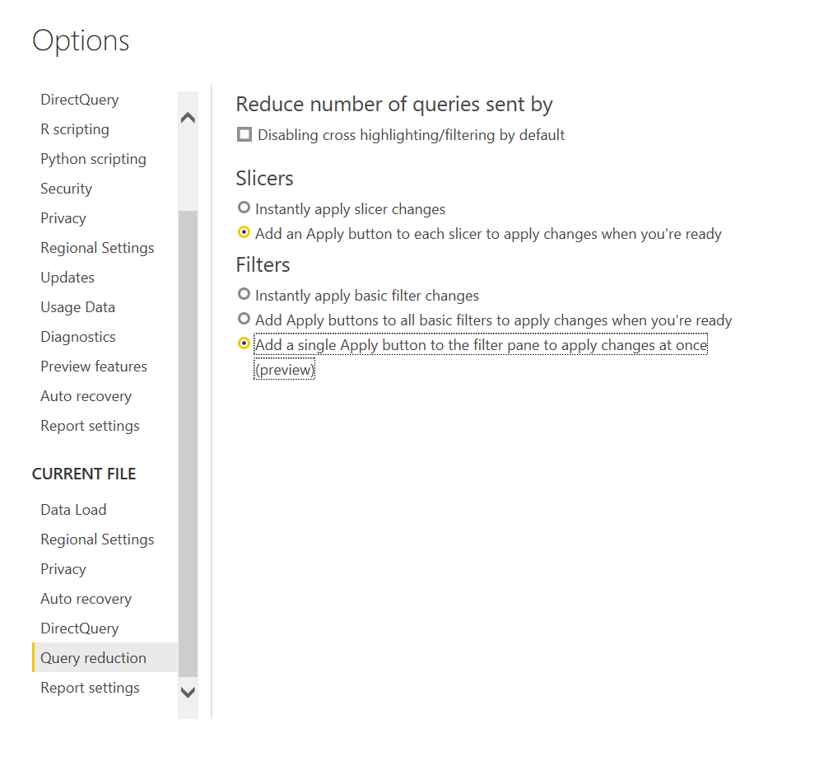

1. **Use drill through buttons to generate an intuitive user experience**

* Enable drill through buttons; these are more intuitive than right click on data points.
* Use conditional formatting to make the text on the button context-driven.

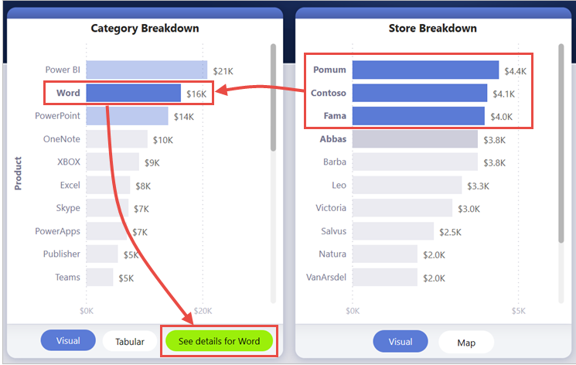

1. **Optimize your data model for better performance.**

* Unused columns should be removed
* Indexing of the columns that are commonly filtered
* Keep a check on the precision of the fields, remove columns with unnecessary precisions.
* Some DAX functions get tested every row of the table, try to avoid them when possible.
* Use calculated measures instead of calculate columns for better performance. And push them to the source wherever possible.
* Use slicers sparingly.

1. **Company Logo**

* Use the Logo in their background.

1. **Data Timestamp to show, when it was refreshed last.**

* We can implement it, to show the end user, when the data was refreshed last.

1. **Less use of scrollable Page**

* End users always feel difficulty when the report has a scrollable page.
* We do not recommend making the page scrollable if not necessary.
* Instead of making page scrollable, use Bookmark and Selection Pane.
* Census dashboard doesn’t have a scrollable page which is good.

## Only import necessary fields and tables

* You can keep the model as narrow and lean as possible by importing only necessary fields. Power BI works on columnar indexes where longer and leaner are preferred.

## Optimizing the environment

* You can optimize the Power BI environment by configuring capacity settings, sizing data gateways, and reducing network latency.

### Capacity settings

* When using dedicated capacities—available with Power BI Premium (P SKUs), or Power BI Embedded (A SKUs, A4-A6)—you can manage capacity settings.

### Gateway sizing

* A gateway is required whenever Power BI must access data that isn't accessible directly over the Internet.
* You can install the [on-premises data gateway](https://docs.microsoft.com/en-us/power-bi/connect-data/service-gateway-onprem) on a server on-premises, or VM-hosted Infrastructure-as-a-Service (IaaS).